FRANCE BASED COMPANIES BOOKING FORM
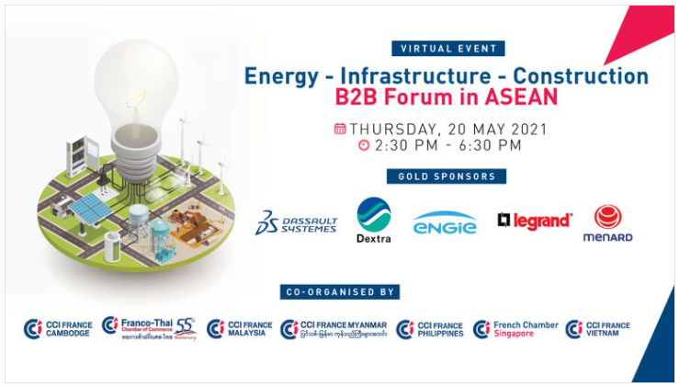
VIRTUAL EVENT B2B FORUM IN ASEAN

Join the panel discussions and meet with key players from the Energy-Infra-Construction sectors through a virtual platform dedicated to B2B meetings!
Match, Accelerate, Collaborate

For over a year now, the COVID-19 pandemic has considerably restricted travel, suspended all meetings and any opportunity to network in several sectors of activities.

A very dynamic yet diverse zone, ASEAN presents a variety of needs in terms of infrastructure with Smart City solutions in supercities as well as basic infrastructure coverage needed in developing countries.

With 650 million inhabitants, equivalent to 9% of the world’s population, and a large young, urban and connected population, ASEAN attracts an increasing number of companies to respond to the needs of the public and private sectors investors in construction, equipment, distributors of components, engineering offices and architecture.

Presented by The French Chamber of Commerce in Singapore along with the French Chamber of Cambodia, Malaysia, Myanmar, Philippines, Thailand and Vietnam,

This half-day B2B Forum in ASEAN consists of:

- An overview of the potential in the ASEAN Region: get detailed insights on 7 potential markets for future business development;
- 6 round-tables on the topics of Energy, Construction & Infrastructure;
- A Business Matching session of 2 hours with qualified B2B meetings to meet with potential clients, partners and investors from ASEAN.

Programme

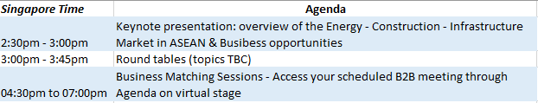

 € 300* per company (for 1 participant) - € 321 inclusive of local GST (7%)
- 1 access to the digital platform (keynote presentation + round tables)
- Qualified B2B meetings – digital link (up to 8) (to be booked online)
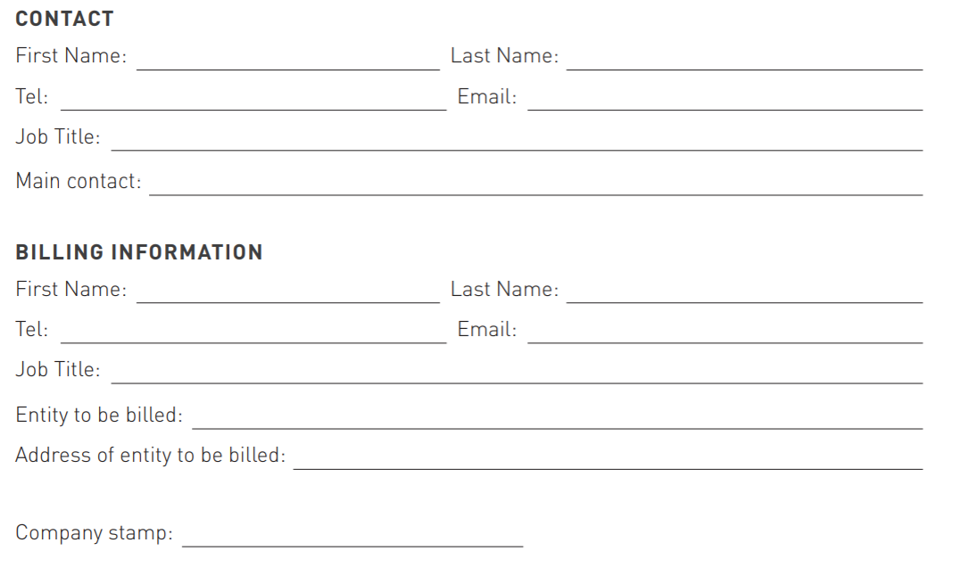

French Chamber in Singapore Contacts
For any questions on the event, please contact:
- tbeaumond@fccsingapore.com
- asimon@fccsingapore.com

*All prices exclusive of GST
NB: The French Chambers reserve the right to cancel the Energy Infra B2B Forum in the event of a force majeure (including but not limited to fire, accident, attack, natural disaster, epidemic) or other external major incident beyond the control of the organiser. Such cancellation or interruption shall not entitle sponsors and participants to any right of reimbursement of any sum paid or damages of any nature.

